SQL Server Migration from a Current server to a new server

**Summary**

|  |  |
| --- | --- |
|  |  |
| **Author(s)** | Chris Borman |
| **Role** | Database Manager |
| **Title** | SQL Server Migration from a Current server to a new server |
| **File Name** |  |

**Sign-Off**

|  |  |  |
| --- | --- | --- |
| **Name** | **Role** | **Date** |
| **Chris Borman** | Senior Manager of Database Operations/Author |  |
| **Phill Wade** | Head of Technology Management/ Service Ops |  |
|  |  |  |

**Version**

|  |  |  |
| --- | --- | --- |
| **Number** | **Date** | **Description** |
| **0.1** |  | Initial Draft |
|  |  |  |
|  |  |  |
|  |  |  |
|  |  |  |

Pre Migration Steps on Current Server

These are pre migration /pre install steps required when migrating to a new server, this is required whether the server is a new server with a new name or a new server with the same name.

Each of these scripts can be found under S:\Business Intelligence and Informatics\South Plaza\IT Services\TAG\SQL\SQL Scripts\Database or Server Migration Scripts.

1. Script out Logins

The first script to run is called ***1. SQL Server - sp_help_revlogin.sql***, run this against the master database, this will set up a couple of stored procedures that will create the logins.

Once the script has been run open a new query and run the command ***EXEC sp_help_revlogin*** save the results to your local machine.

1. Script out Database mail

Run the script ***2. SQL Server - Reverse Engineer SQL Mail.sql***, copy the results of the Item column to a new query and save the results to your local machine.

1. Script out server roles

Run the script ***3. SQL Server - CreateSQLServerUserRoles.sql***, copy the results to a new query and save the results to your local machine

1. Script out linked servers

Run the script ***4. SQL Server – CreateLinkedServers.sql***, copy the results to a new query and save the results to your local machine.

1. Script out the operators

Run the script ***5. SQL Server - Create mail operators.sql***, copy the results to a new query and save the results to your local machine.

1. Script out SQL Jobs by doing the following
   1. In Object Explorer, connect to an instance of the Microsoft SQL Server Database Engine, and then expand that instance.
   2. Expand SQL Server Agent, expand Jobs, and highlight all the jobs you want to script. Note exclude the maintenance plans from this.
   3. From the right-click menu, select Script Job as, then CREATE To and click New Query Editor Window, which opens a new Query Editor window and writes the Transact-SQL script to it.
2. Script out Integration Services packages by doing the following
   1. In SQL Server Management Studio connect to Integration services and select the server you want to export the packages from.
   2. Click on Stored Packages then MSDB as shown below.

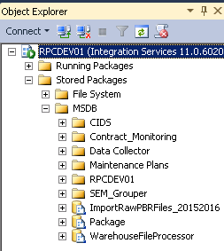

* 1. Where you are saving your results, create folders based on the folder names i.e. CIDS
  2. Within the folder in integration services right click and choose export package

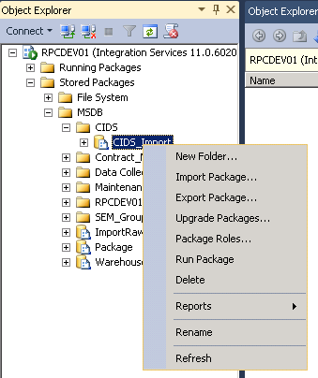

* 1. Browse to the location you created in step c, click Save and OK

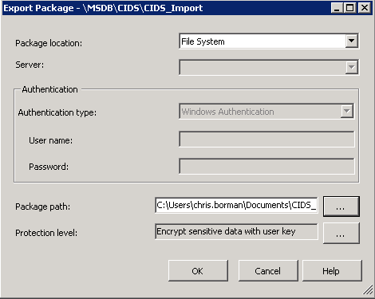

* 1. Repeat until all packages have been exported.

1. Backup SSISDB Service Master Key

To do this you will need to open up the script.

* Check in the password spreadsheet what the master key encryption is and add it where the password is specified file to
* Choose a location to save the backup to
* Choose an encryption password
* Check in the password spreadsheet what the service master key encryption is and add it where the password is specified file to
* Choose a location to save the backup to
* Choose an encryption password

1. Create a restore script

Run the script ***7. SQL Server - Create Restore Script.sql***, copy the results to a new query and save the results to your local machine.

The next step is to move onto the SQL Server Build, the documentation can be found in S:\Business Intelligence and Informatics\South Plaza\IT Services\TAG\SQL\Documentation\ SQL Server 2012 Install Documentation.docx.

Once the Install is completed, move on the post migration steps below.

Post Migration Steps on New Server

This part of the document will cover the rebuilding on the new server, all of the requirements come from the scripting taken from the pre migration steps.

1. Create the Logins provided by running ***EXEC sp_help_revlogin***.
2. Run the script to create Database mail from the results of ***2. SQL Server - Reverse Engineer SQL Mail.sql***.
3. Recreate the server roles from the results of ***3. SQL Server - CreateSQLServerUserRoles.sql.***
4. Recreate the linked servers from the results of ***4. SQL Server – CreateLinkedServers.sql***.
5. Recreate the operators from the results of ***5. SQL Server - Create mail operators.sql***.
   1. Recreate the SQL Jobs from the scripted job as created earlier
6. Recreate the Integration Services packages by doing the following
   1. In SQL Server Management Studio connect to Integration services and select the server you want to import the packages from.
   2. Click on Stored Packages then MSDB, then create the folders as per the ones you created earlier, i.e. CIDS
   3. Within the folder in integration services right click and choose import package

-------------------------------------------------------------------------------------------------------

* 1. Browse to the location you created in step c, click Save and OK



* 1. Repeat until all packages have been exported.

1. Backup SSISDB Service Master Key

To do this you will need to open up the script.

* Check in the password spreadsheet what the master key encryption is and add it where the password is specified file to
* Choose a location to save the backup to
* Choose an encryption password
* Check in the password spreadsheet what the service master key encryption is and add it where the password is specified file to
* Choose a location to save the backup to
* Choose an encryption password

1. Create a restore script

Run the script ***7. SQL Server - Create Restore Script.sql***, copy the results to a new query and save the results to your local machine.